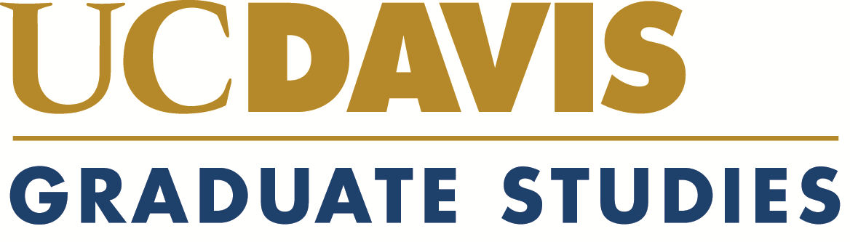

Alfred H. and Marie E. Gibeling Fellowship

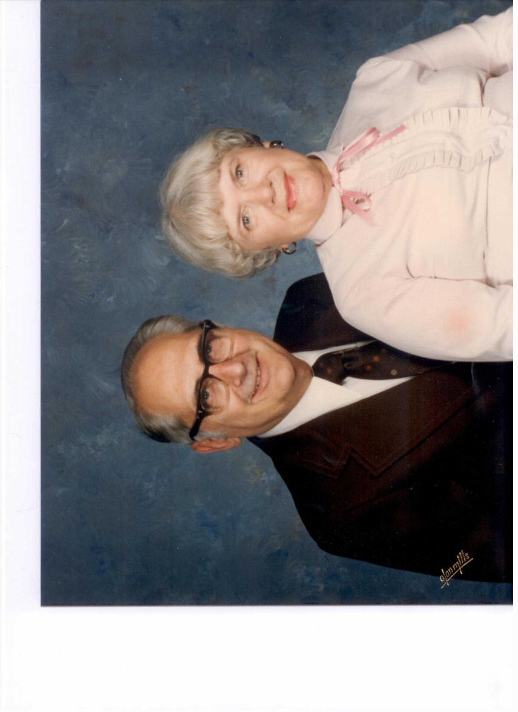



Alfred H. and Marie E. Gibeling

Alfred H. Gibeling was born on August 8, 1921 in Fort Leavenworth, Kansas and Marie E. Gibeling was born on August 20, 1915 in Oshkosh, Wisconsin. They were married in 1951 in Oshkosh. They have one son, Jeffery, who lives with his wife Marsha in Davis, and a grandson Gregory and his wife Stella.

Alfred graduated in 1943 with a degree in Mechanical Engineering from Georgia Tech. He was employed by Allis Chalmers Company in steam turbine design and later by General Atomics Company working on power plant design. After retirement, he worked on gas turbine power plant design at Solar Turbines until 2001. Marie attended Oshkosh State Teachers College and worked as the executive assistant to the president of A. O. Smith Corporation until 1951.

Alfred and Marie were residents of Milwaukee, Wisconsin and San Diego, California. They met on a golf course and continued to enjoy golfing together and later sailing with their son on San Diego Bay. Together, they established the Alfred H. And Marie E. Gibeling Fellowship which was awarded for the first time in 2010.

Alfred Gibeling passed away in August, 2011. Marie Gibeling continues to reside in San Diego and recently celebrated her 97th birthday.

About the Fellowship:

The Alfred H. and Marie E. Gibeling Fellowship is awarded to the most outstanding students in the areas of advanced materials research or energy
conservation technologies. This is a nine-month fellowship open to continuing graduate students.

Recipients:

Lilian Chang
Chemical Engineering and Material Science
Alfred H. and Marie E. Gibeling Fellow (2010-2011)

David Nisson
Physics
Alfred H. and Marie E. Gibeling Fellow (2012-2013)

